**A**

**SYNOPSIS**

**ON**

**Agriculture Automation With Automated Shelter System For Crop Protection & Pulse Generating Electric Fencing**

## 

## DEPARTMENT OF ELECTRICAL ENGINEERING

PRESCRIBED BY

## [Dr. Babasaheb Ambedkar Technological University](https://dbatu.ac.in/), Lonere



Submitted by

**Mohit R. Khobragade**

**Saloni D. Chambhare**

**Damini G. Lidabe**

**Sakshi B. Dupare**

Under the Guidance of

Prescribed by

## Rajiv Gandhi College of Engineering, Research and Technology - [RCERT], Chandrapur - Faculty Details 2022-2023

Submitted by

**MOHIT R. KHOBRAGADE**

**SALONI D. CHAMBHARE**

**DAMINI G. LIDABE**

**SAKSHI B. DUPARE**

Under the Guidance of

## Prof. S. Y. KAMDI

## RAJIV GANDHI COLLEGE OF ENGINEERING, RESEARCH AND TECHNOLOGY, CHANDRAPUR

**2021-2022**

**4 PHASES OF OUR PROJECT**

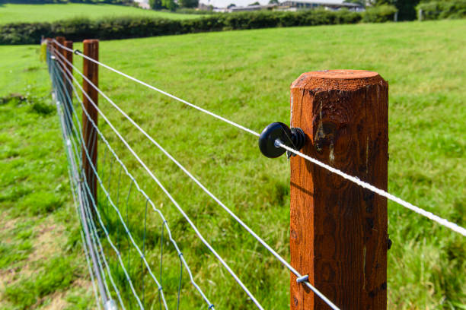 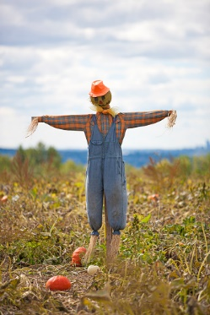

**PULSE GENERATING ELECTRIC FENCING** **AUTOMATIC SCARECOW WITH PIR SENSOR & SERVOMOTOR**

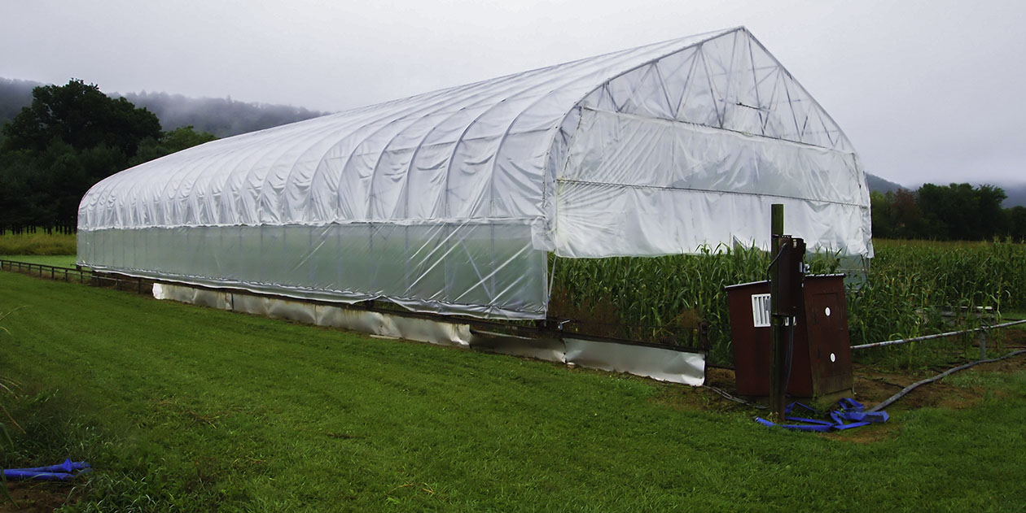 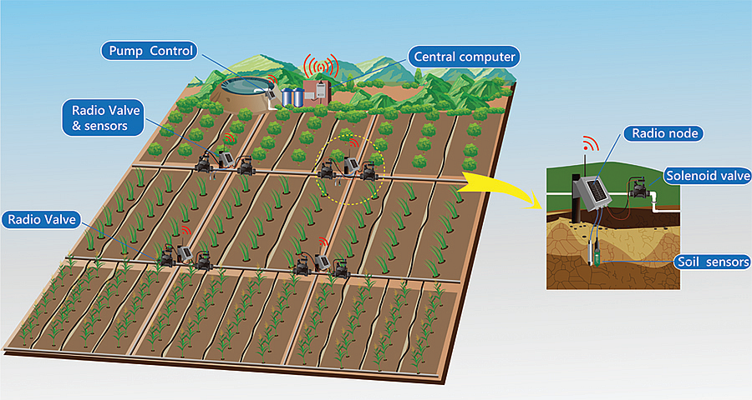

**AUTOMATED SHELTER SYSTEM WITH RAIN SENSOR AUTOMATIC PUMPING SYSTEM WITH SOIL SENSOR**

**ABSTRACT –**

Agriculture is the most traditional activity over time. Since the beginning of it, agriculture has suffered many changes to improve productivity and quality of crops. Some of the first significant improvements have been remarked when machines and new tools such as irrigation systems, harvest machines, farmland clearing machines were introduced in the primitive agriculture, where these activities were performed mainly by humans and animals. Over time, agriculture has been affected by weather disasters (such as storms or extreme temperatures) and by natural disasters (such as pests and plant diseases). Thus, the next step in the development of the agriculture domain was to propose the Internet of Things (IoT) solutions for monitoring of many parameters for better precision agriculture. Such a system would provide useful information on plant growth, crops’ diseases, and soil properties that are a benefit for crops. This paper describes a possible solution for a more reliable IoT based system using rain drop sensor, Crop protection system from animals and birds and Automatic shelter system.

**INTRODUCTION**

Internet of Things (IoT) is widely used in connecting devices and collecting data information. Internet of Things is used with IoT frameworks to handle and interact with data and information. In the system users can register their sensors, create streams of data and process information. IoT are applicable in various methodologies of agriculture. Applications of IoT are Smart Cities, Smart Environment, Smart Water, Smart Metering, Security and Emergency, Industrial Control, Smart Agriculture, Home Automation, e-Health etc. ‘Internet of Things’ is based on device which is capable of analysing the sensed information and then transmitting it to the user. Why do we need IOT in agriculture? From survey of United Nations – Food and Agriculture Organisations, the world wide food production should be increased by 70% in 2050 for evolving population. Agriculture is the basis for the human species as it is the main source of food and it plays important role in the growth of country’s economy. It also gives large ample employment opportunities to the people. The farmers are still using traditional methods for agriculture, which results in low yielding of crops and fruits. So the crop yield can be improved by using automatic machineries. There is need to implement modern science and technology in the agriculture for increasing the yield. By using IoT, we can expect the increase in production with low cost by monitoring the efficiency of the soil, temperature and humidity monitoring, rain fall monitoring, fertilizers efficiency, monitoring storage capacity of water tanks and also theft detection in agriculture areas. The combination of traditional methods with latest technologies as Internet of Things and Wireless Sensor Networks can lead to agricultural modernization. The Wireless Sensor Network which collects the data from different types of sensors and send it to the main server using wireless protocol. There are many other factors that affect the productivity to great extent. Factors include attack of insects and pests which can be controlled by spraying the proper insecticide and pesticides and also attack of wild animals and birds when the crop grows up. The crop yield is declining because of unpredictable monsoon rainfalls, water scarcity and improper water usage.

**LITERATURE SURVEY**

Nikesh Gondchawar et al., [1] proposed work on IoT based smart agriculture. The aim of the paper is making agriculture smart using automation and IoT technologies. Smart GPS based remote controlled robot will perform the operations like weeding, spraying, moisture sensing etc. It includes smart irrigation with smart control and intelligent decision making based on accurate real time field data and smart warehouse management. It monitors temperature maintenance, humidity maintenance and theft detection in the warehouse. All the operations will be controlled by smart device and it will be performed by interfacing sensors, ZigBee modules, camera and actuators with microcontroller and raspberry pi. All the sensors and microcontrollers are successfully interfaced with three Nodes using raspberry pi and wireless communication. This paper gives information about field activities, irrigation problems, and storage problems using remote controlled robot for smart irrigation system and smart warehouse management system respectively.

Rajalakshmi P.et.al., [2] described to monitor the crop-field using soil moisture sensors, temperature and humidity sensor, light sensor and automated the irrigation system. The data from sensors are sent to web server using wireless transmission and JSON format is used for data encoding to maintain server database. The moisture and temperature of the agriculture field falls below the brink, irrigation system will be automated. The notifications are sent to farmers mobile periodically and farmers can be able to monitor the field conditions from anywhere. The parameters used here are soil moisture sensor, temperature and humidity sensorDHT11, LDR used as light sensor and web server – NRF24L01 used for transmitter and receiver. This system will be more useful in areas where water is in scarcity and it is 92% more efficient than the conventional approach. Automation of irrigation system data was stored in MySQL database using PHP script. Total average power consumption is 2 Ah per day for a single motor pump and water requirement analysis.

Tanmay Baranwal et al., [3] this project concentrates security and protection of agricultural products from attacks of rodents or insects in the fields or grain stores. Security systems are used to provide real time notification after sensing the problem. Sensors and electronic devices are integrated using Python scripts. Algorithm is designed based on collecting information to provide accuracy in notifying user and activation of repeller. Testing is done in an area of 10 sq. m. and the device is placed at the corner. The PIR sensor identifies heat it starts URD sensor and webcam. Based on attempted test cases 84.8% success is achieved. It will be helpful to extend the security system to prevent rodents in grain stores.

Nelson Sales et al., [4] this paper describes Wireless sensor Networks. The network performs three nodes i.e. acquisition, collection and analysis of data such as temperature and soil moisture. The benefits of irrigation process in agriculture are decreasing water consumption and environmental aspects. Cloud Computing is an attractive solution for high storage and processing capabilities of large amount of data by the Wireless Sensor and Actuator Network. This work aims to agriculture, greenhouses, golf courses and landscapes. Architecture is divided in to three main components: a WSAN component, a cloud platform component and a user application component. It contains three different types of nodes such as sink node, a sensor node and an actuator node. SimplitiTI is a simple protocol for WSAN implementation in a cluster tree topology. The soil moisture monitors to assess the plants it need water for its proper development and optimization of natural resources.

Mohamed Rawidean Mohd Kassim et al., [5] this work describes a Precision Agriculture (PA). A WSN is the best way to solve the agricultural problems like farming resources optimization, decision making support, and land monitoring. Using this approach provides real-time information about the lands and crops that will help the farmers to make right decisions. Precision agriculture systems based on the IOT technology explains the hardware architecture, network architecture and software process control of the precision irrigation system. The software collects data from the sensors in a feedback loop depending on that activates the control devices based on threshold value. Implementation of WSN in PA optimizes the usage of water fertilizer through irrigation and also maximized the yield of the crops.

LIU Dan et al., [6] this paper describes greenhouse technology in agriculture represents the design and implementation based on ZigBee technology using CC2530 chip. It is mainly used for environment monitoring system. The wireless sensor and control nodes uses CC2530F256 core for data acquisition, data processing, data transmission and reception. Here computer provides all the real time data for the concerned person using wireless communication like temperature control, fans condition. In this system uses intelligent monitoring and control of green house. It is helpful to farms for scientific and balanced planting crops.

**WORKING**

Our project will be handled by Node MCU microcontroller. Soil sensor will monitor moisture present in soil so that controller can switch on and off water pump automatically. Rain detection sensor will detect rain so that roof of garage can open and close accordingly. Electric fencing is used to keep animal away from farm. PIR Sensor will detect birds and switch on scarecrow

**BLOCK DIAGRAM**

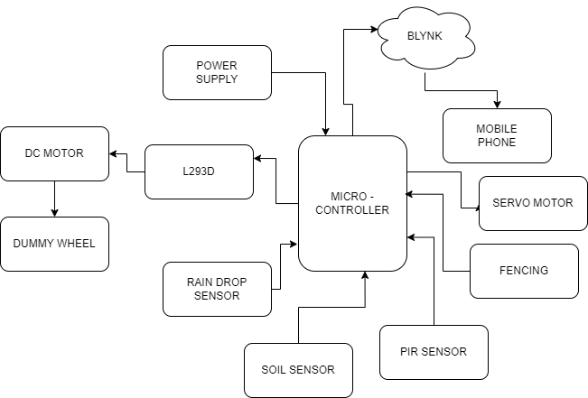

**HARDWARE REQUIREMENT**

1. NodeMCU
2. Rain Drop sensor
3. L293D Motor driver IC
4. DC motor
5. Dummy Wheel
6. Soil Sensor
7. PIR Sensor
8. Servo motor
9. Fencing

**SOFTWARE REQUIREMENT**

1. Arduino IDE
2. Diptrace
3. Blynk Application

**ADVANTAGES**

1. Increased Production. ...
2. Water Conservation. ...
3. Real-Time Data and Production Insight. ...
4. Lowered Operation Costs. ...
5. Increased Quality of Production. ...
6. Accurate Farm and Field Evaluation. ...
7. Improved Livestock Farming. ...
8. Reduced Environmental Footprint.

**DISADVANTAGES**

The smart agriculture needs availability of internet continuously. Rural part of most of the developing countries do not fulfil this requirement. Moreover, internet connection is slower.

**REFERENCES**

[1] C. Kamienski, et al., “Application Development for the Internet of Things: A Context-Aware Mixed Criticality Systems Development Platform,” Computer Communications, Vol. 104, May 2017, p. 1-16.

[2] Applications of IoT in Agriculture, https://www.iotforall.com/iot-applications-in-agriculture/, accesed on April 2019.

[3] European-Parliament Precision Agriculture: An Opportunity for EU Farmers—Potential Support with the CAP 2014-2020, http://www.europarl.europa.eu/RegData/etudes/note/join/201 4/529049/IPOL-AGRI_NT%282014%29529049_EN.pdf, accesed on April 2019.

[4] Sjaak Wolfert, Lan Ge, Cor Verdouw, Marc-Jeroen Bogaardt, “Big Data in Smart Farming – A review”, Agricultural Systems, Elsevier, 2017.

[5] Renewable Energy Sources – A Brief Summary http://www.alternative-energy-tutorials.com/energyarticles/renewable-energy-sources-a-brief-summary.html, accesed on April 2019.

[6] Libelum’s new Smart Agriculture Extreme Sensor Node Provides Maximum Accuracy for Crop Monitoring, http://www.libelium.com/libeliums-new-smart-agriculturextreme-sensor-node-provides-maximum-accuracy-for-cropmonitoring/, accessed on April 2019.

[7] FAO, Disasters in agriculture, http://www.fao.org/news/story/es/item/1107192/icode/, accessed on April 2019.

[8] Developing Smart Agriculture with IoT Technologies, https://www.haptic.ro/developing-smart-agriculture-iottechnologies/, 2016, accesed on April 2019.

[9] Duan Yan-e, Design of Intelligent Agriculture Management Information System Based on IoT Fourth International Conference on Intelligent, Computation Technology and Automation 2011, Volume: 1 Pages: 1045 – 1049. [10] F. Karim, F.Karimb, and A.Frihidab, “ Monitoring system using web of things in precision agriculture,” Procedia Computer Science 110, Tunis, Tunisia, 2017, pp. 402–409, 2017. [11] I. Zyrianoff, A. Heideker, D. Silva, C. Kamienski, “Scalability of an Internet of Things Platform for Smart Water Management for Agriculture,” Proceedings of the 23rd Conference of Open Innovations Association FRUCT. FRUCT Oy, 2018, p. 58.